HFCs AND FLUORIDES - GREENHOUSE COOLANTS HARMFUL TO GLOBAL WARMING

GIOIETTA KUO

NOV 2016

ABSTRACT
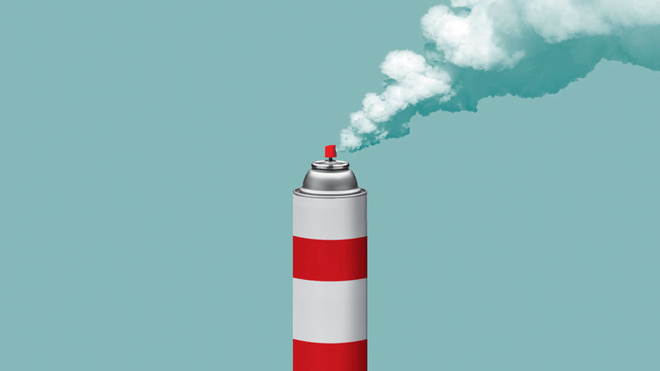
The world found that the use of chlorofluorocarbons CFCs used in refrigerants and air conditioners was causing the depletion of the atmospheric ozone layers which protect us from harmful ultra violet rays from the sun. In 1987, 24 countries met to produce the MONTREAL PROTOCOL ON SUBSTANCES THAT DEPLETE THE OZONE LAYER to phase out the use of CFC’s. It is one of the rare successes of international cooperation. However, in doing so the world replaced CFC’s by hydrofluorocarbons, HFCs, which though do not harm the ozone layer but stay in the atmosphere for a very long time having a large effect on global warming. In July 2016, countries of the Montreal Protocol met in Vienna to try to replace HFC’s. Fortunately alternatives exist such as Hydrofluoroolefins - HFOs which break down in the atmosphere in some days instead of years.
Progress is being made and in October 2016 amendment to the Montreal Protocol to phase out HFCs has been reached in Kigali, Rwanda.

INTRODUCTION
While we think about the emission of CO2 as the harmful gas that causes global warming, there are in fact some other gases we should also worry about although they are produced in smaller quantities. But these pollutants can trap heat in the atmosphere at levels a thousand times higher than carbon dioxide can,

In this article we list the entire list of green house gases with particular emphasis on fluorocarbons which are produced entirely by humans as the other leading atmospheric pollutants. Here we compare their impact on global warming by two characteristics:

- How long they stay in the atmosphere?
- Their ability to absorb energy and slow the rate the energy escape to space - radiative efficiency. We define here a ˝Global Warming Potential” (GWP) Using carbon dioxide emission as a reference which we define as equal to 1, GWP provides a measure of the energy each gas will absorb for one ton of gas over 100 years. The range of GWP listed is from IPCC's Fifth Assessment Report, published in 2014. [1][2]

LIST OF GREENHOUSE GASES

* CARBON DIOXIDE CO₂ - produced by burning fossil fuels: coal, natural gas and oil. By definition its GWP is 1

- METHANE, CH₄ - emitted through the transport and production of coal, natural gas ( fracking) and oil. Also from livestock. GWP is in the range 28-36 . This shows methane is superior to CO2 for heat trapping

- NITROUS OXIDE N₂O - produced during agricultural and industrial activities. GWP is in the range 265-298.

- FLUORINTED GASES - [1] under heading Fluorinated Gases. These are:

- HYDROFLUOROCARBONS (HFCs), lifetime in the atmosphere is from 1 to 270 years its Global Warming Potential GWP is in the range 12,000- 14,800

- PERFLUOROCARBONS(PFCs). Lifetime in the atmosphere is 2,600 -50,000 years. Its ˝Global Warming Potential GWP is 7390 - 12200.

- NITROGENTRIFLUORIDE (NF₃) Lifetime in the atmosphere is 740 years. Its Global Warming Potential GWP is 17,200

4. SULFUR HEXAFLUORIDE(SF₆) lifetime in the atmosphere is 3,200 years. Its Global warming Potential GWP is 22,800

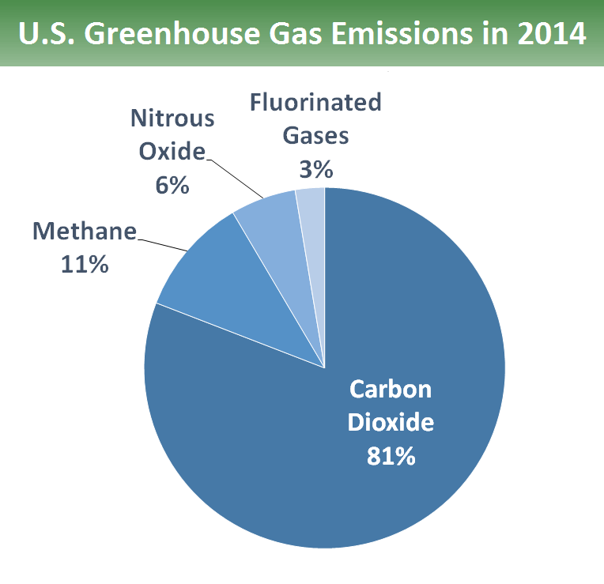
As can be seen, these fluorides stay in the atmosphere for horrendously long periods. This means that HFCs would contribute up to 10% of global greenhouse emission by 2050.

PIE CHART 1 [3]
we show here a pie chart of the proportion of the greenhouse gas emissions in the US in 2014. From Environmental Protection Agency EPA
Total Emissions in 2014 = 6,870 million metric tons of CO₂ equivalent

PIE CHART 2 [3]

Sources of Greenhouse
Gas Emissions.
Data US. From Environmental Protection Agency EPA

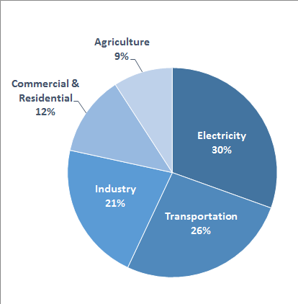
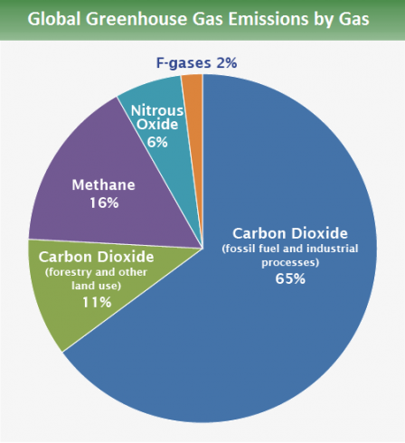
PIE CHART 3 [4]

Source IPCC(2014)
From Contributions of Working Group III to the Fifth Assessment report of the Intergovernmental Panel on Climate Change

MONTREAL PROTOCOL

In 1987, 24 countries met for a meeting called the Montreal Protocol on Substances that Deplete the Ozone Layer. it had been found that the use of chlorofluorocarbons CFCs used as refrigerant in refrigerators and air conditioners were causing the deletion of the atmospheric ozone layers which protects us from the harmful ultra violet rays from the sun. The meeting was very successful and a phasing out and banning of chlorofluorocarbons was decided upon.

This Montreal Protocol is one of the rare successes of the international cooperation and it was eventually signed by 197 countries. It has resulted in s 97% reductions in the production and import of ozone deleting substances.

However, the protocol’s exclusive focus on stopping ozone depletion left a loophole. Industry swapped CFCs for hydrofluorocarbons HFCs, resulting in a 258 percent increase in the use of heat-trapping HFCs used in refrigerators, air-conditioners and aerosols. An agreement to phase down and ban the use of HFCs under the Montreal Protocol would avoid an estimated 105 gigatonnes of carbon dioxide equivalent by 2050, and up to 0.5°C of global warming by the end of the century, while continuing to protect the ozone layer.

So in 15-26 July 2016, parties took a critical step towards their goal under the Dubai Pathway to amend the Montreal Protocol to reduce the production and consumption of hydrofluorocarbons, HFCs. [5]

Fortunately, there are alternatives to HFCs. Propane can be used as a coolant in small air-conditioners at a fraction of the climate impact of HFCs, and ammonia is an industrial coolant with no greenhouse effects. The cost of the phase down would means a price of $8-10 billion over the next 3 decades, equivalent to to 8 or 10 cents on the dollars per ton of carbon dioxide.

President Obama has been active on the diplomatic front and secured agreement from India’s prime minister Modi and China’s President Xi Jinping to the phasing out of HFCs - the two countries which produce and use them widely. There is however disagreement on the time scale over the phasing out. Most countries support some form of a deal to phase out HFCs, but certain ones with developing economies, led by India, are pushing for a slow timeline. While the United States wants a deal that would phase out production of HFC in five years, India is pushing for 15 years because of the hot climate which will need more air conditioners. The Montreal Protocol provides for a fund to help developing countries. Much of this funding will come from US, Canada, Japan and EU.

CONCLUSION

However, although the Paris accord on climate change in December 2015 is only partially legally binding and some countries like Brazil and the Philippines have already said they will not follow it. It is hoped that the present amendment to the Montreal Protocol will result in something which will have the force of law in almost every country. This would give it more potency then the Paris agreement which lacks the binding force of a treaty.
Finally on October 15 2016 [6], more than 170 countries of the Montreal Protocol met and reached an amendment in Kigali, Rwanda to the phasing out of the use of HFCs. There are 3 sections depending on the economy of the countries:
- Richest countries like US and EU will freeze the production and consumption by 2018, reducing them to 15% of 2012 levels by 2036.
- Most countries of the world including China, Brazil and all of Africa will freeze the use by 2024, reducing it to 20% of 2021 levels by 2045
- A small group of hottest countries - India, Pakistan, Iran, Saudi Arabia and Kuwait will have the most lenient schedule, freezing the use by 2028 and reducing to about 15% of 2025 level by 2047.
Major industries like Honeywell are developing replacements to HFCs by Hydrofluoroolefins - HFOs which break down in the atmosphere in some days instead of years.

REFERENCES
1. “Overview of Greenhouse Gases - US Environmental Protection Agency”
https://www.epa.gov/ghgemissions/ov...

2. “Understanding Global Warming Potentials | Greenhouse Gas (GHG ...”
https://www.epa.gov/ghgemissions/un..

3 “U.S. Greenhouse Gas Inventory Report: 1990-2014 | Greenhouse Gas ...”
https://www.epa.gov/ghgemissions/us-...

[4] Global greenhouse Gas Emission Data . from ref [1]

[5] “News Releases from headquarters: Air and Radiation (OAR) Statement on the Montreal Protocol Negotiations in Vienna, Austria” EPA, July 23, 2016

[6] “Nations, Fighting Powerful Refrigerant That Warms Planet, Reach Landmark Deal” Coral Davenport, New York Times on amendment to Montreal Protocol, October 15 2016

[6] “ Montreal protocol on track to reach 2016 HFC Amendment” Business Wire
http://www.business wire.com/news/home/20160724005034/en/Montreal Protocol

---------------------------
Gioietta Kuo, from Cambridge, Oxford and Princeton, is a research physicist specializing in energy problems. She has published over 100 articles in World Future Society, wfs.org, amcips.org and other worldwide think tanks. As well as in ‘ People’s Daily’ and ‘World Environment’ , Magazine of the Chinese Ministry of Environmental Protection, and others in China. She can be reached at <kuopet@comcast.net.>

