Countries with Large Volumes of Variable Resources Face Difficulties with Grid Stability

- by 2GreenEnergy Intern Olivier Goavec

When the Kyoto protocol was signed in 1997 in an effort to slow the pace of global warming, many countries began to change their approach towards energy. For example, the EU has adopted in 2008, an internal agreement to produce 21% of its electricity from renewable sources by 2020. The region follows an economic policy to foster the investors, providing attractive kWh feed-in tariffs. In France for example, the government via EDF (the historical electricity supplier) has the obligation to redeem the electricity from sustainable energy at a higher price than that at which it sells, causing an explosion sector. The most popular sources are solar, photovoltaics, onshore wind turbines, and, more recently offshore wind turbines. Energy from the sea, like tidal, are at the beginning of their development curve, and do not have the maturity of wind turbines or solar panels. Nevertheless, the amount of power from those new technologies is becoming a key driver of our energy production, which is why it is important to know if this new means of production affects the electrical grid.

A little historical reminder: the first electrical grids arrived in developed countries at the end of the 19th century; New York City received its first grid in 1882. At that time the main question was: do we have to use direct current or alternating current? Indeed both had their advantages and inconveniences. Alternating current won, because its voltage was easier to modify thanks to transformers, which had already been invented. The modification of the voltage amplitude is really interesting when you want to transmit your electricity over long distances because the higher the voltage is, the less losses you have. This is due to the joule effect which is proportional to the square of the current. For the same power you want to transport, the current will be smaller if the voltage is higher (P=UI²). Because of that, most electrical grids of the world are in AC.

Another important point is that electricity is very hard to store, which means the production has to match consumption. If you don’t respect that, you may have some voltage dips, an over-current, or a modification of the frequency into the grid. We must avoid this because it can damage the facilities. It is easy to understand how difficult it is to match consumption with production only during the day, (for solar panels) or only if the wind happens to be blowing (for wind turbines); it implies a huge meteorological work which complicates the task of those who regulate the electricity into the grid.

Originally the electrical grid had been designed to transfer the plant’s current to the consumer. The scheme was descending, as shown here:

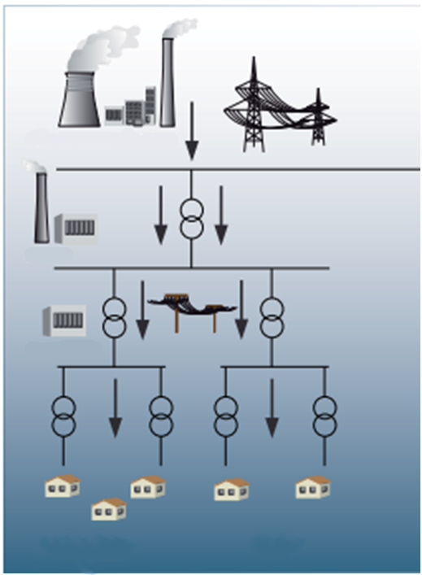

Descending flow

Consumers

Electrical plant

Before the renewable energy revolution of these last past years, there was no problem, because the grid was exploited in accordance to the way it was originally built. But today everyone can make his own electricity, we just have to put a solar panel on our roof or a wind turbine in our garden. The scheme here is both ascending *and* descending; the consumer injects his electricity into the grid.

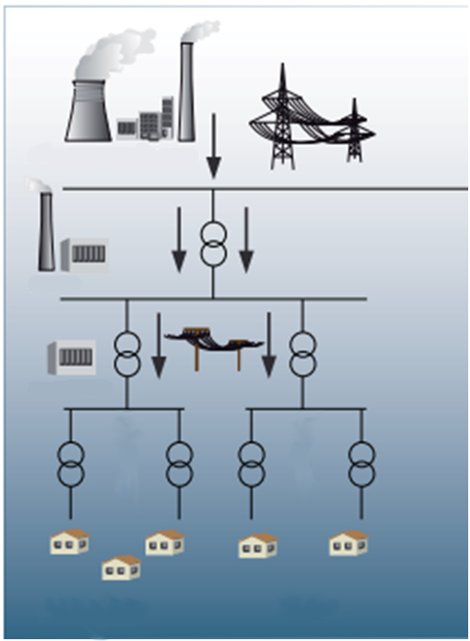

Ascending flow

Descending flow

Consumers/producers

Electrical plant

This is a real challenge facing the deployment of sustainable energy in terms of security and feasibility. Imagine a place where there is a good amount of sun exposure at most times during the day: naturally people of that region will want to install solar panels in order to earn money or simply out of ecological conscience. Eventually this will represent an important amount of power that has to be transported, but the grid may not be strong enough for this, or maybe the grid protections will not be maintained in place.

In addition, there are other issues due to the utilization of sustainable energy, like the quality of the electricity and its impact onto the grid or the difficulty in forecasting the weather.

The electrical current is composed of a voltage and a current which are both sinusoidal. They have a frequency (50 or 60Hz depending on the country) and an amplitude (120 or 230 Volts). It is extremely important to respect these values in order to avoid a black out. Today’s electrical plants know how to maintain these parameters, thanks to a strong regulation system - but they are not alone anymore. The electrical grid is global; everything is interconnected. If something happens in one particular area of the grid, it could affect the whole system.

One problem with renewable energy is the random factor of the weather. The wind or the sun are not constant, which means the power production from wind turbines or solar panels vary. Therefore, the weather can affect the frequency or the tension of the grid. The frequency is linked to the active power: imagine all the turbines from an electrical plant spinning to provide active power and a 50 or 60Hz signal; if you are sampling them and demand more energy, all the turbines will have to supply more power, but at some point it won’t be possible and the turbines will slow down and the frequency decreases. It’s as if you were riding your bike and the road begins to rise, you need more power to be able to turn the pedals at the same frequency. That kind of problem can occur when a wind farm stops producing suddenly, because there is a power drop into the grid. Some people disagree with this analogy, and point out that if the wind doesn’t blow somewhere it will be blowing somewhere else, thereby the power doesn’t really fall in the grid. But we have to understand that this argument is not really possible today. Indeed the onshore and, offshore wind farms or solar farms are getting bigger and bigger. Let’s take the example of the last offshore wind farm in the UK named *London Array,* which is also the biggest in the world*.* As of today, that wind farm has an installed capacity of 640MW, and specialists hope a load factor of 40%. It has been designed to produce electricity for almost 460,000 homes. If a facility like London Array doesn’t produce electricity because the wind is not blowing, the grid will have difficulties. That lack of power can be difficult to fulfill, hence a modification of the frequency. The frequency is generally allowed to vary between ±0.5Hz of the setpoint. Beyond that, if no solutions are found we have to disconnect some parts of the grid to rebalance the production to the consumption.

We also may have some disturbance in the voltage. As I said earlier, the amount of power from renewable energy fluctuates, and this can generate “flickers”. These flickers result from a fluctuation of the voltage, and the phenomenon can be seen with a modification in the brightness of a lamp. Overvoltage and voltage drops usually cause overheating of the equipment, resulting in a premature aging of them.

Flickers:

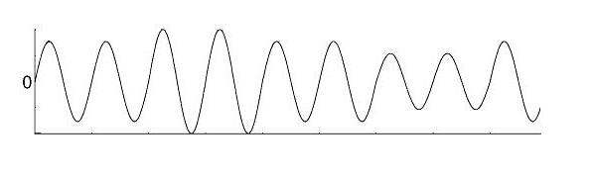

Amplitude

Time

Another difficulty is that sometimes we can’t directly inject the current we produce into the grid. Solar panels don’t allow that, though certain kinds of wind turbines do. For solar panels the explanation is simple: they produce DC current so we need to convert the DC in AC via power electronics. Wind turbines support a type of connection, generally called type 4 or D, where the AC current produced by the engine is transformed in DC with a rectifier, then put in AC into the grid with an inverter. That command is useful if you don’t want to be at the mercy of power or frequency fluctuation of the wind turbine. It also allows users to control the amount of reactive power on the grid because you can regulate the phase shift between the voltage and the current. Generally the electrical suppliers ask for a power factor close to 1 (0.93 minimum in France). Only the active power is needed to run our electrical devices; reactive power causes extra losses. In both situations we use power electronics, resulting in what we call harmonics. Those harmonics slightly deform the electrical current, which is not a problem if you have very few wind turbines or solar panels. But imagine a whole wind farm, which can also perturb communication frequencies and create additional losses.

Harmonics:

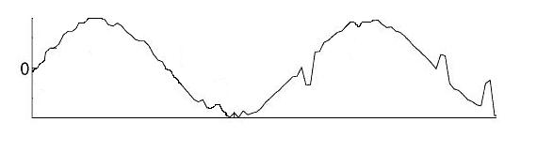

Amplitude

Time

We can see that we don’t have a perfect sinusoid.

It follows that we need some security rules; e.g., a wind farm must be able to disconnect its wind turbines from the grid if the quality of the electricity into the electrical network is too low, or if the amount of power in the grid is too high. (If there is too much power the frequency will increase.)

Hopefully, the establishment of smart grid is making progress and will soon become essential to manage the electrical network. A smart grid is, as its name implies, “smart”. It means that it is a grid with a multitude of sensors; it is able to know in real time what the consumption of electricity is. The principle is easy: each house/plant/wind farm etc, of a country, have a smart-meter which sends to its electricity manager all the information it needs (consumption and production all along the day). This way, it is easier to regulate the grid and adapt the exact amount of power that is needed. This technology has a lot of advantages:

• integrates the power from renewable energy more easily

• reduces failures from the grid by not overloading it

• reduces electricity losses by delivering just the right amount of power

• improves the ability to locate a failure inside the electrical network

• improves behavior on the part of consumers and reduces electrical consumption

In a report from the United States Department of Energy, they write “If the grid were just 5% more efficient, the energy savings would equate to permanently eliminating the fuel and greenhouse gas emissions from 53 million cars”. Obviously, this would represent a real impact on the environment.

To conclude we can say that our electrical grid is changing, the arrival of sustainable energy as “electrical plants” forces our suppliers to invest in their installations. Maybe the development of green energy has been too fast for them. Let’s not forget that it costs a lot to reinforce the grid and its protections; it is a difficult task which takes time and money. That’s why today we face some difficulties in the development of those types of energy. But we are at the beginning of something new and everybody is learning. I think all those problems will be solved in a few years, thanks to new regulation and a greater knowledge.

Olivier Goavec

<http://energy.gov/sites/prod/files/oeprod/DocumentsandMedia/DOE_SG_Book_Single_Pages.pdf>

PDF p7