

**This technology compresses AIR to generate electricity**!

We appreciate your interest in helping to save our environment by investing in the world’s most advanced green technology that **compresses and accelerates AIR at rapid speeds to generate electricity!**

Since air is abundant, unlimited, and perpetual, the equipment can operate efficiently day and night indefinitely.    The price for this equipment ranges from under US $2 million to produce 1 MW on up. It uses no fossil fuels, leaves no carbon footprint, releases no emissions that contribute to global warming, and has a wide range of commercial and residential, marine, and automotive uses planned. Orders are being processed now for this equipment to generate up to 17 MW. Multiple 20 MW units could be used in larger cities.

The billions of dollars saved by no longer needing to import oil, natural gas, coal, uranium, and other expensive energy products can be re-invested into each country's economy, which would lead to exponential acceleration of national wealth..

* Let us know how you see yourself being involved in this fantastic much-needed technology that should be Nobel Prize winner.

* Are you an investor or lender who would like to fund the project for the US $100 million needed or a 1 MW Reactor for under US $2 million? Creative options and flexibility exist, including possible territory exclusivity.

**We arrange a conference call for serious investors to talk directly with the project** **head** to have all questions answered, to be given a quotation for their needs, to receive documents needed, and to save a lot of time in determining the preferred geographical location, range of monies, and by-product desired.

We have been prioritizing on seeking funding for the much-needed quite lucrative Waste to Energy (WTE) plants that convert landfills into electricity and fuel worldwide and will continue…..adding this fantastic technology as an option.

.

We look forward to working with you to help make a better world!

**Jan Marie Bjorklund** [**FundingCatalyst@aol.com**](mailto:FundingCatalyst@aol.com)

[**http://www.linkedin.com/in/janmariebjorklund**](http://www.linkedin.com/in/janmariebjorklund)

**ConfCall: 712-432-0800-1035081# {Intl CC:  209-255-1000-403501#}**

**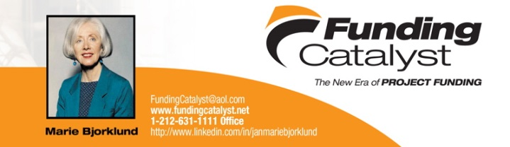                                                                             The spark that makes dreams a reality!**